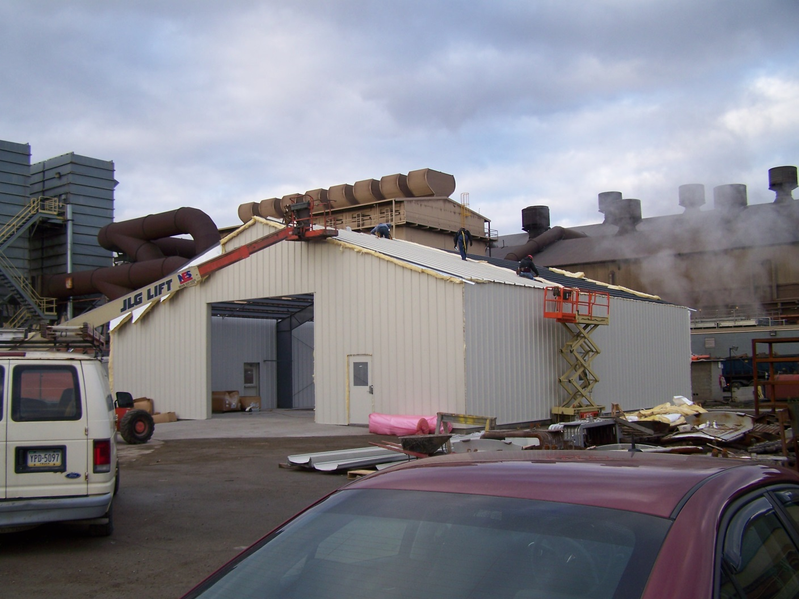

**EQS Storage Facility in New Castle, Pennsylvania**

**Erection by Lee Michael Industries, Inc**